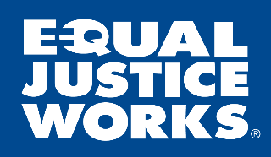
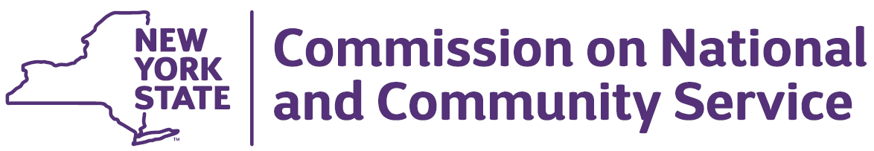
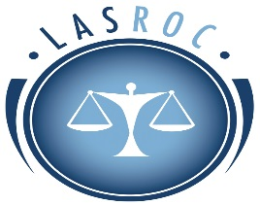

Organization: The Legal Aid Society of Rochester, New York

Fellowship: Equal Justice Works Americorps Fellow, New York State Family Security Project Based in Rochester, New York
The Legal Aid Society of Rochester, NY is hosting a one-year fellowship sponsored by Equal Justice Works designed to foster family security and community education through the provision of legal immigration services. The attorney selected for the Fellowship will be housed at the Legal Aid Society’s office at 1 West Main St. in Rochester, New York. Per Equal Justice Works/AmeriCorps guidelines, the fellowship must begin no later than January 2, 2017, and last for one year.
Fellowship Description:
The Equal Justice Works New York State Family Security Project Legal Fellow will:
- Represent clients in immigration court and before U.S. Citizenship and Immigration Services (USCIS)
- Advocate for equal access to the naturalization process for immigrants with disabilities
- Develop screening process to identify individuals who require an accommodation or another legal remedy to meet naturalization requirements
- Prepare naturalization applications for clients with disabilities, including the necessary accommodation, oath waiver or power of attorney
- Possible representation of individuals in guardianship proceedings before New York State courts
- Engage pro bono attorneys to provide legal assistance to immigrants and their families
- Provide community education regarding the challenges faced by the immigration system by an individual with disabilities
- Develop professional relationships with disability rights advocates and refugee-serving agencies
- The position is a one-year Fellowship, with a possible one-year extension contingent upon continued AmeriCorps funding.

Qualifications:

The ideal candidate will have the following:
- Attorney admitted to the New York State Bar
- The ability to undergo and pass AmeriCorps-mandated criminal background checks (only conviction for murder and presence on sex offender registry are automatic bars to service; other criminal convictions are allowable under Equal Justice Works review and approval)
- A demonstrated commitment to public interest work and strong desire to assist indigent clients
- Strong writing, communication, interpersonal, and organizational skills
- The ability work collaboratively in a variety of contexts
- Prior experience in managing independent projects or assignments
- Law school clinic, externship, summer or other relevant practice experience a plus
- The ability to begin the fellowship no later than January 2, 2018.
- Those with experience in regards to immigration issues strongly encouraged to apply
- Willingness to attend a mandatory substantive immigration law training in New York City in January 2018, as well as the mandatory Equal Justice Works Leadership Development Training in Washington, DC in October 2018 (Note that travel costs for these training will be covered by Equal Justice Works)
Salary:
The Fellow will receive an annual living allowance, as well as financial support for housing, student loan repayment, and other permissible reimbursable living expenses. Additionally, Fellows receive an education award, health insurance, and other benefits. Interested applicants should contact The Legal Aid Society of Rochester, NY with any follow-up questions.
Other Benefits and Professional Opportunities offered by AmeriCorps:
- Student loan forbearance and interest accrual payment upon successful completion of service
- Opportunity to attend national training focused on leadership, networking, and project development sponsored by Equal Justice Works
- Childcare assistance (if income eligible)
The Legal Aid Society of Rochester, NY Immigration Unit provides legal representation, advice, and information to non-citizen community members and their families. We seek to vigorously defend the individual rights of our clients to ensure that they are treated with dignity, equality, and respect.

Application Instructions:

Please respond with your Resume, Cover Letter, References, and Writing Sample to Legal Aid Society of Rochester, Attention HR, 1 West Main Street, Suite 800, Rochester, NY 14614 or https://lasroc.bamboohr.com/jobs/view.php?id=24

Please respond no later than December 15, 2017. Your cover letter should refer to the Equal Justice Works AmeriCorps Fellowship position. Applications will be reviewed as they are submitted. The Equal Justice Works AmeriCorps Fellow is scheduled to begin the term of service no later than January 2, 2018.

The Legal Aid Society of Rochester is an Equal Employment Opportunity Employer and does not discriminate by race, color, religion, sex, sexual orientation, national or ethnic origin, age, disability or veteran status.

Application Deadline: December 15, 2017, but candidates are encouraged to apply as soon as possible.

